# 



# School of InfoComm Technology

**Data Visualisation**

Diploma in FI

October 2020 Semester

**ASSIGNMENT 1**

**(Individual Assignment)**

**Submission Deadline:**

**20th December 2020 (Sunday), 11:59PM**

|  |  |  |
| --- | --- | --- |
| **Tutorial Group** | **:** | **P01** |
| **Student Name** | **:** | Tan Zi Xu |
| **Student Number** | **:** | S10185168 |

**Penalty for late submission:**

10% of the marks will be deducted every calendar day after the deadline.

**NO** submission will be accepted after 24th Dec 2020 (Thursday), 11:59PM.

Contents

Project Objectives 2

Target audience 4

Exploratory question list 5

Data Preparation 7

Data cleansing & transformation 8

Metadata research 9

Exploratory Data Analysis and Visualisation 10

Univariate & multivariate analysis 10

A.Hotel Distribution 10

B.Booking counts 11

C.Guest to booking count (children) 13

D.Highest number of booking in each month 14

E. Booking against cancellation per month 15

F. Cancellation rate 17

G.Country origin 18

H.Market segment 20

I. Distribution channel 21

J. Reserved Room against Assigned Room 22

K.Deposit type distribution 25

L. Customer type distribution 25

Explanatory question list refresher 27

Dashboards 28

# Project Objectives

This report is written with the objective to understand, prepare and clean the dataset with hotel reservations information of a city hotel and a resort hotel. Based on the dataset, meaningful exploratory question will be identified to gain insights for the targeted audience. The identified question will be solved by deriving from a set of visualizations designed to answer the questions.

The main topic I would like to explore in this report is on overbooking in hotel industry. The term, “overbooking”, is something I am very interested to learn more about. Especially when the term gain notoriety from the United Airlines incident back in 2017, where a passenger was forcibly removed. In summary, the root cause of the incident was due to the airline overbooking the available seats for the flight. While the term appeared on a different industry, overbooking is actually very popular term in hoteling. As a matter of fact, overbooking is one of the more common strategy to maximise revenue generation in hoteling.

Overbooking in hotel refers to the hotel selling more rooms to customer than what the hotel is capable of supplying. The disproportion in supply and demand could land potential visitors without a room despite making reservation. To a customer, it is not an enjoyable circumstance, they only want the room that they had made reservation for. However, it is something that can affect the hotel’s revenue and profits.

As providing a room is a hotel’s room primary service, having an empty room for the night would be equivalent to losing potential revenue of that night. Hotel wants to ensure that their rooms are being occupied efficiently to maximise their revenue. Hence, they adopt overbooking strategy while taking in account of the potent last-minute cancellations for the strategy to work.

From one perspective, hotel overbooking can be seen as gambles that risk a lot on the line for the hotel. As a badly optimized overbooking strategy can leave undesirable damages on the public relation (PR) image, with poor online reviews consequently harming its reputation and the potential financial loss. A recent example that happened in Singapore was at Grand Park Orchard hotel on 12 December 2020. Singapore has issued SingapoRediscovers vouchers nationwide that can used on local hotel stays. Hence, a sizable number of Singaporean opted to use it for staycation and there was huge influx of booking for the hotel. Which resulted in overbooking and the negative reviews came pouring. It left horrendous damage on the hotel’s PR image and customer looking to cancel their staycation.

On the other hand, it is the opportunity to grow the revenue at consistent rate with a well optimized strategy, where the rooms would be occupied by at least one customer at any given day. All in all, adopting an overbooking strategy is an intelligent, calculated gamble with high rewards and low risk if it is properly optimized.

As for why overbooking actually occurs, where the strategy failed and creates a problem, there are a few reasons. First, an unforeseeable event can take place and leaving the rooms unsuitable for service, reducing the number of operational rooms. Next, there could be poor management or decision made in handling the bookings. Lastly, there could be booking taking place simultaneously, where bookings for the same room comes through different channels. Resulting in the booking at the same time by different people and it is a fault that cannot be pinned on anybody. As it could happen within a small timeframe that the management will not be able to notice this issue.

Referring back to the Grand Park Orchard incident, a spokesperson stated that the hotel tried to contact customers to manage the check-in times but it was a challenge to reach all of the customer. While the hotel management is not entirely accountable for the issues due to potential oversight, it is important that lessons from the incident are studied.

With this setting, I believe this is an opportunity for me explore insights on a topic I am interested in. My exploratory questions would be able to help my target audience gain meaningful insights on adopting or optimizing their own overbooking strategy. Hence, I have list of 4 main exploratory question with overbooking in hotel as the topic in mind. The list be formatted such that each question is supported by various visualization. The report will also cover on my target audience followed by data preparation. The data preparation will demonstrate my understanding of the variables I am working with along with cleansing and transformation. The report will then cover the analysis and visualizations. To finish the report, there will be 4 dashboards representing each of the exploratory questions.

## Target audience

The target audience in general are hotel managements, which can be branch out to various departments within hotel environment. Some examples are the booking management, PR management or even marketing department. The report is also not limited to hotel on its own, competitors or hotel up start may also learn from this report to help optimize their own overbooking strategy. The following exploratory question list will explain the motive of creating the question and where the information can be applied.

## Exploratory question list

### What are some seasonal trends of bookings?

This question is made to understand which a point of time throughout the year will hotels see an increase or decrease in booking counts. It will help booking manager to optimize the strategy to adapt to different seasons. It may also help marketing people look for timeframes to do specialized advertising for the hotel. Allowing management to come up with seasonal special product at the right time.

### What is max availability of operational rooms for each hotel?

When running an overbooking strategy, it is important to know how many operational rooms are in stock. The room inventory value is a key value to know how much a hotel can overbook. By following a logic that if a room was booked, it could represent it is operational. Finding the day with high number of booking within each month and getting the average is the target value. Reason being the average value would represent the maximum number of operational rooms at any point of time. This information would be vital for booking managers.

### What is the overbooking limitation?

When running a risky strategy, knowing the line not to cross can yield great rewards. By understanding their limit, hotels can safely run overbooking strategies. Hence, exploration into bookings against cancellation by month will help better understand any correlation between booking counts and cancellation counts. However, additional findings into cancellation rate is real objective of this question. By find the cancellation rate, management can give an estimation of how much to overbook.

### Based on the booking distribution, what improvement can be done?

This question was made to find out where are bookings coming from. To identify which channels did it came from and what market was targeted by the hotel. By understanding where the customer base origins are, products or business opportunity can be found with greater understanding on the customer. Know the distribution channels of the booking enables potential improvement toward business process to be found. An improvement such as streamlining could elevate some constraint on the booking department. Lastly, understanding the market segmentation can open up more opportunity in expanding advertising to different markets.

### What has been done to deal with overbooked customers?

This is an important question when running overbooking strategy. There needs to be a plan in case rooms were overbooked and mitigation of PR damages is of importance. An understanding of rooms available in the hotels is needed before identifying any overbooking has taken place along with how frequent the occurrence is. Measures of upgrading room for customer to compensate for overbooking if any can be evaluated here. From there exploration into type of deposits can be made to find option in refunding as a way to mitigate PR damage. Lastly, understanding customer type distribution can assist in finding the best course of action by relating to what type of customer is being dealt with.

# Data Preparation

Using Jupyter Notebook, python and the pandas library, I was able to get some general information on the data set. I can conclude the raw state of the data set is rather clean with a few null values in certain variables such as children, country, agent and company. There were also negative values in the average daily rate column, which is likely to be dirty data.

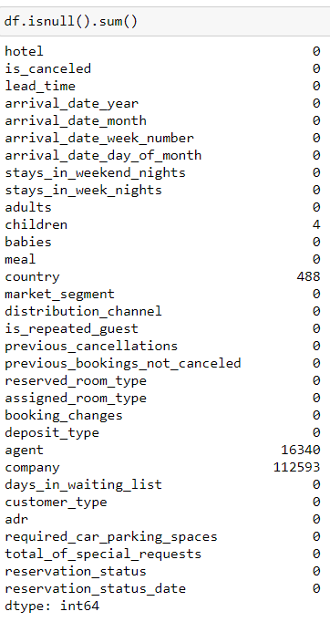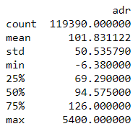

## Data cleansing & transformation

For data cleansing and transformation, I will be cleaning the data, transforming some variables and prepare a couple of new variables.

In cleaning, I will be dropping rows with null values in country or negative values in average daily rates. This is done to ensure my dataset is clean for analysis without irregular rows missing or have weird values.

In transformation, I will be working on dealing with the remaining variables with null values. The null values of children will be assigned as “0”, it is an assumption to default the value to the minimum. The variables in agent and company will undergo transformation for the analysis. As the agent and company codes assigned by the hotel is irrelevant to me, all null cells will get “0”. This will set the variables in a context more suitable for analysis related to counting or identifying.

The reason for only dropping nulls in country instead of transformation is that I want to avoid decreasing the size of the dataset. However, I am unable to assign random or common values to the nulls in country.

For additional new variables added, there are only three of them and both of which are derived from existing columns. The first column, “arrival_date_month_int”, is just to convert the month name into numbers it corresponds to. The next column, “arrival_date”, is a combination of three different variable to form an actual date instead of individual components. Lastly, there is the “is_canceled(Str)” column, it is derived from the original “is_canceled” column. However, the values were transformed to string that would represent the values. Instead of remembering the meanings to values of 1s and 0s, it is easier categorise cancelled and non-cancelled bookings this way.

In the tableau workbook, the agent and company data type were also transformed from integers to string. As the values were not intended to be aggregated but to be identification code.

## Metadata research

For metadata research, the term GDS found in distribution channel pique my interest. Hence, I did some research on the term and what it means in the hotel industry. The GDS stands for Global Distribution System, it is primarily a platform to connect travel bookers and hotels or accommodation providers. It holds information on price and availability of rooms up for booking. It is a convenient tool when bookings need to be made for trips. GDS is suited for hotel with room inventory of more than 20 rooms. Seasonal trends also do not affect the booking counts. GDS is beneficial for hoteliers in many ways and implementation of such system can be very useful. GDS specialises in bookings for corporate travels and it has untapped potential to outpaces bookings generated from direct channel. Since information is stored altogether in a platform, travel agencies and tour operators can search up hotels that fits their client’s preferences. Hence, the popularity of GDS among travel agencies and tour operators is amassing every year. (GDS hotel: What is a global distribution system?, n.d.)

Another term that I researched into was the term, “complementary”, in the market segment column. It is oddly vague and no additional information was provided in the metadata. However, my research yielded nothing on the term itself, the closest thing I could find was “complimentary”. Which seems too different as hotel typically refer complimentary to add on. For example, additional Wi-Fi service provided are considered complimentary services to the guest’s stay.

# Exploratory Data Analysis and Visualisation

## Univariate & multivariate analysis

### Hotel Distribution

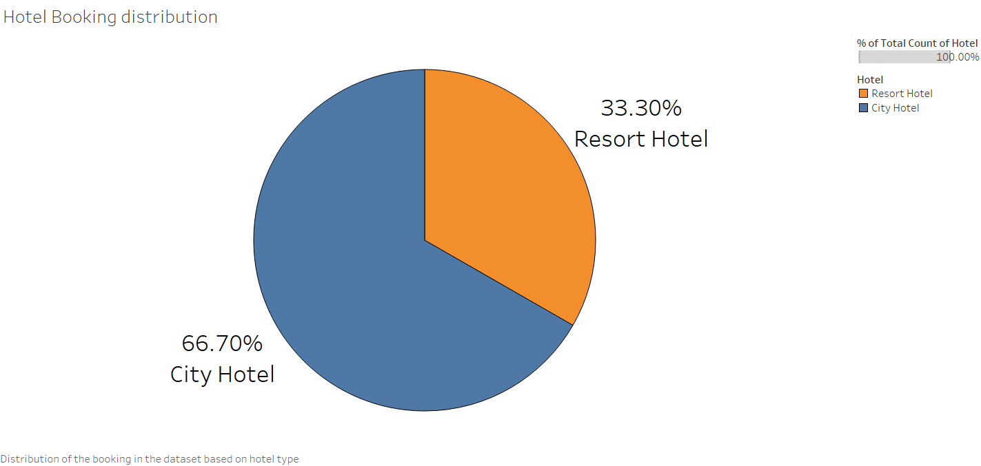

To get a clearer picture of the dataset, pie chart was used to reflect the distribution of the bookings based on hotel type. It showed that the ratio of data available for two different hotels at 2:1 in favour of city hotel as seen in 66.7% is to 33.3%.

For this chart, an alternative chart could be a bar-in-bar chart as a substitute. It could have shown the distribution in a new light in this exploratory phase of the dataset. However, sticking to principle of keeping things simple, I believed using the pie was more straightforward in conveying the visualization’s message.

From this chart, we have to affirm that in future visualization, core findings and insight have to be looked based on the individual hotel type’s context. This is because with both hotel having different data size distribution, it would not be fair to assess the data under the same context.

### Booking counts

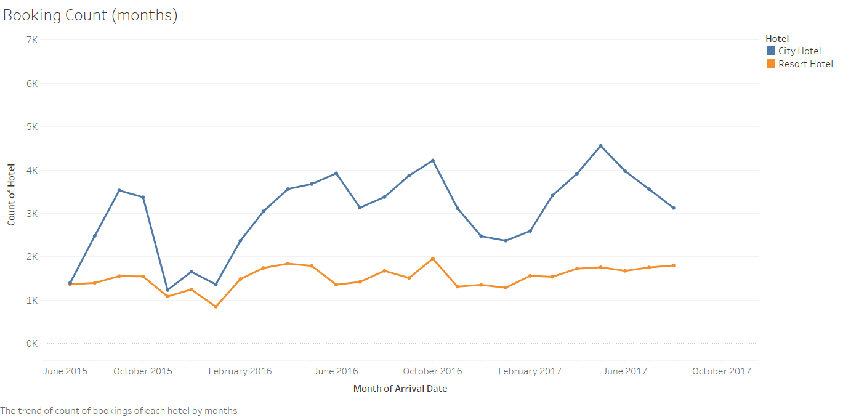

This is a line chart tracking the number of bookings from both hotels for each month. It shows certain periods of increased number of bookings and decline as well within the time frame of the dataset.

An alternative chart could be an area chart, it would show the magnitude of the changes between the months. However, sticking with a line chart helps to pinpoint positions of each frequency mark, making it easier to identify a trend.

Which classify this chart as a supporting visualization to my exploratory question on the seasonal trend of the customers. By utilizing this chart, it gives me a general trend to follow that will me understand the customer.

Overall, this chart was able to reflect the changes between months and attribute a little towards finding trends of the booking. However, to identify the trend between the two hotels, switching the frequency to quarters instead of months might show the seasonal trend.

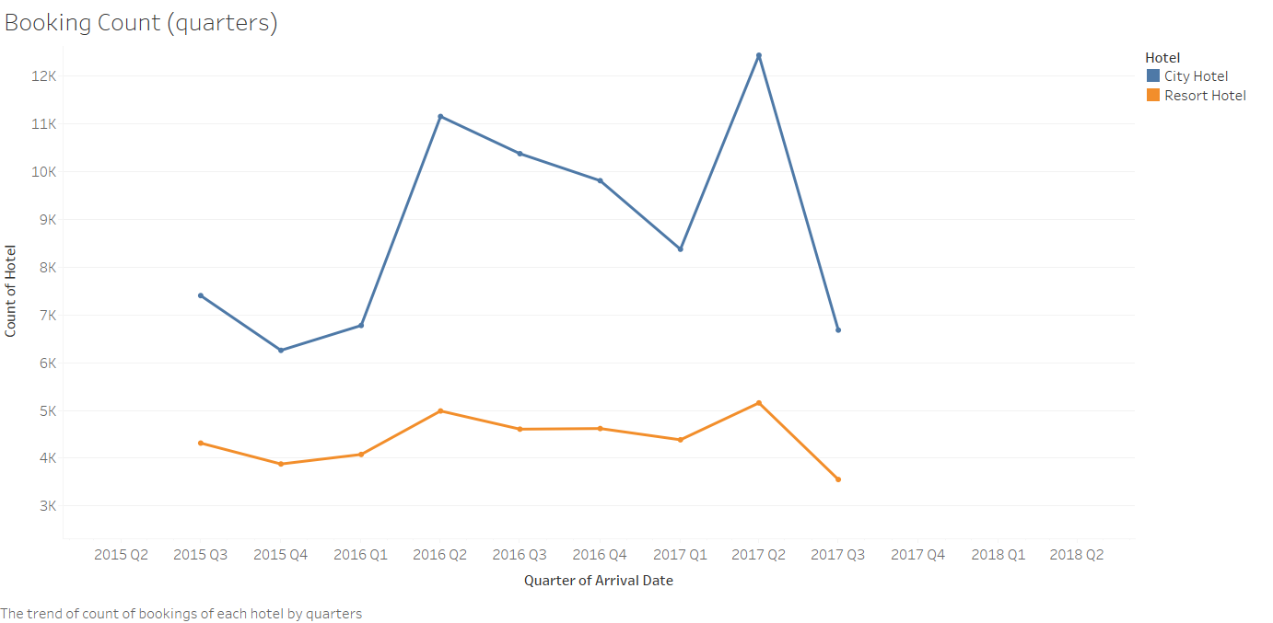

Surprisingly, we can find a noticeable trend that both hotels actually share. It shows the similar trend of a big spike between the first to the second quarter. Finally, there is the eventual declination throughout the remaining quarters of the year.

In this section, there is an assumption that I can make from this chart as to why the spikes in city hotel’s booking is more noticeable. It could be due to the city hotel customer segment is more diverse than the resort hotel. As people who book for resort hotel could be looking to take a vacation but people who book city hotel may have a more general purpose. At the end of the day, bookings for resort hotels are made with a specific purpose. While guest looking to book city hotel in general are likely to only want a roof over their head during their stay. Hence, the city hotel is dealing with a wider range of customer as compared to the resort hotel. Another possible reason could be where the hotels are situated but there is a lack of information to analyse it.

### Guest to booking count (children)

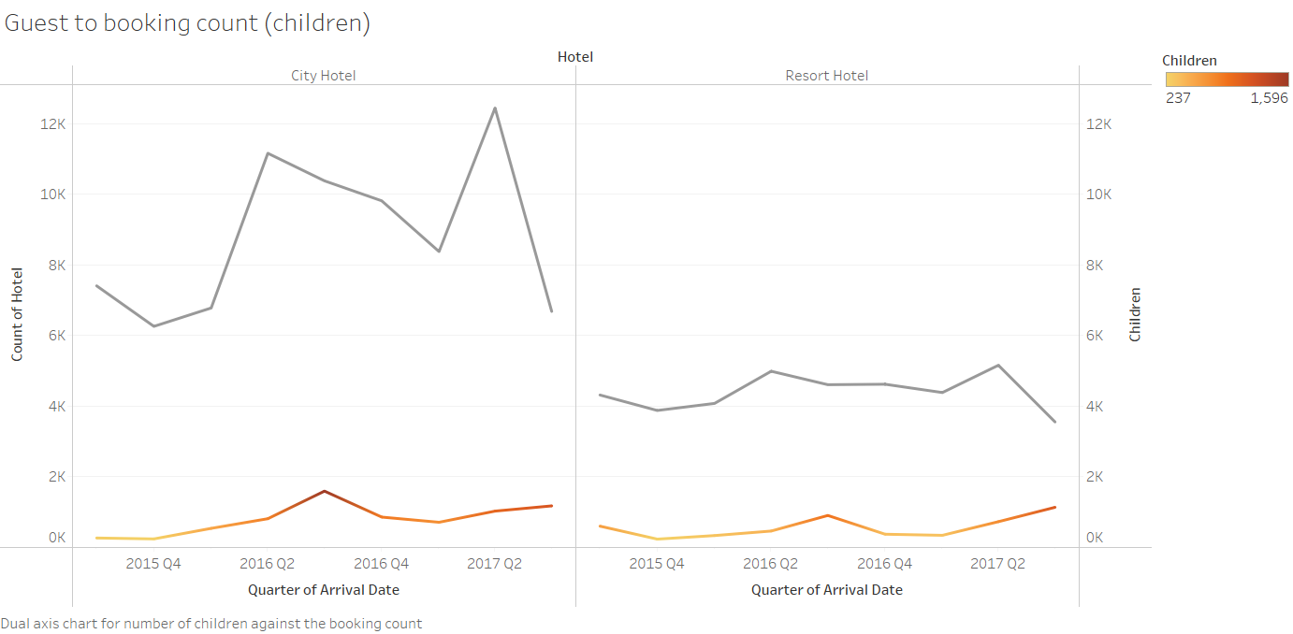

In this line chart, we can compare if there are more children during the spikes in booking counts. This was made with the intent to find affirm the assumption on the trend found in booking count.

Initially, I wanted to use the number of children visiting to see if it correlates to the seasonal trend. Such that the increase in children visiting could represent a vacation break season. Hence, increasing the number of booking made for a vacation.

However, the chart is not an accurate representation that increase in children would in directly increase booking counts. It was an oversight to not take into account of other factors such as different region has different vacation season. There could also be other reason for the booking made but there is no specific indicator in the dataset.

In conclusion of this chart, the chart was made in attempt to help answer the seasonal trend question. It ultimately did not help due to the lack of conclusive findings; various factors were unavailable and not taken into account.

### Highest number of booking in each month

The following charts made in this section are bar charts made with the intention to answer the exploratory question, “What is max availability of operational rooms for each hotel?”.

A tradition bar chart was used here to simply represent days with high booking made within every month. It was done by listing the booking on each day followed by manually keeping the bar with high value in each month. The method was very manual as I could not come up with suitable technique to create the visualization easily nor come up with a suitable substitute. However, it is justified as the visualization is tailored to answer the exploratory question.

This chart was made to identify the highest booking for all 26 months. So that the average of all this value would be the estimation of what is maximum number of rooms that are operational at any given day. Refer to exploratory question list above as why it was needed.

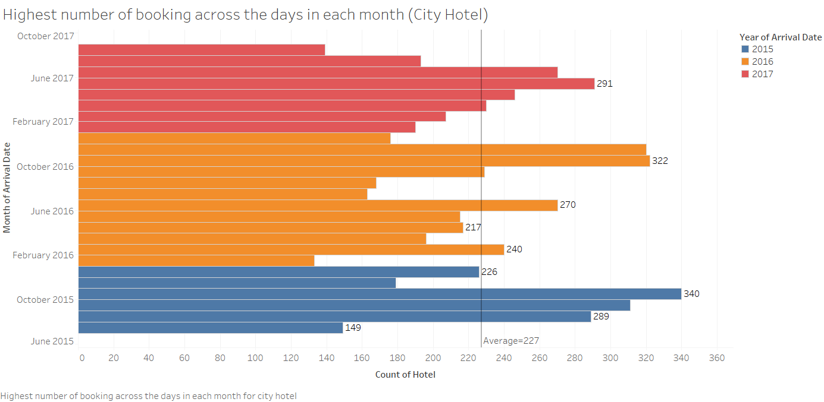

In summary for city hotel, at any given day it is estimated that they would have around 227 rooms would be operational for service of that day. This could be set as reference of their operation room inventory for future optimizing of their overbooking strategy.

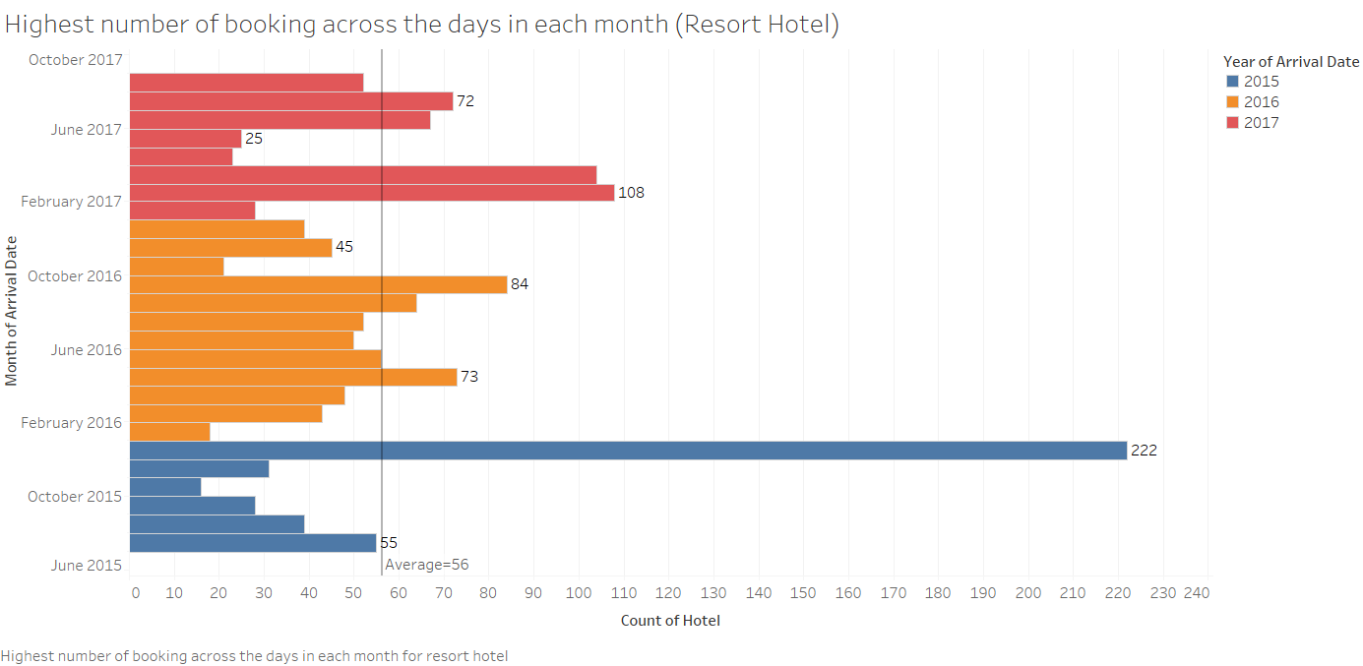

In summary for resort hotel, at any given day it is estimated that they would have around 56 rooms would be operational for service of that day. This could be set as reference of their operation room inventory for future optimizing of their overbooking strategy.

### Booking against cancellation per month

The following charts made in this section are line charts made with the intention to understand the exploratory question, “What is the overbooking limitation?”.

The dual-axis combination chart of area and line with two average reference was used here to help represent a few things. First, it is to reflect standing for both the booking counts and number of cancellations. Next is to enable comparison between the booking counts and number of cancellations. Lastly, to trace the changes between months for both variables. There could be variation in the combination choices, but I deemed area part to be better at tracing the changes in booking and line part to follow along for the cancellation counts.

This chart was made to understand how many bookings were recorded to match against the cancellation. Refer to exploratory question list above as why it was needed.

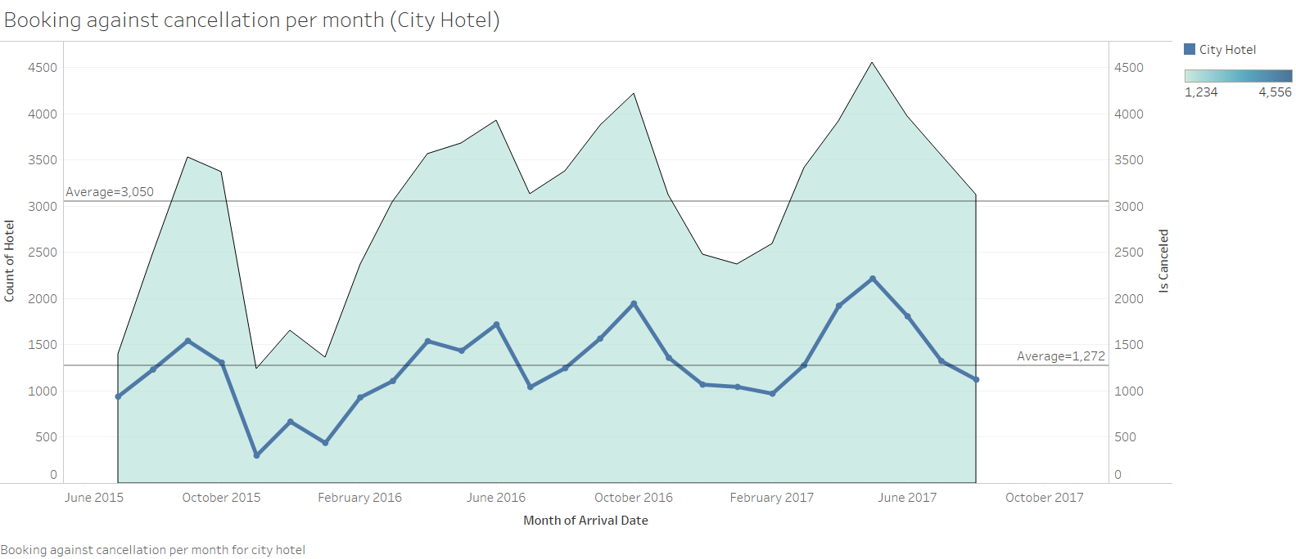

For city hotel, we can see how the booking count and number of cancellation correllate with each other. As trend in both variables are scaling up and down together.

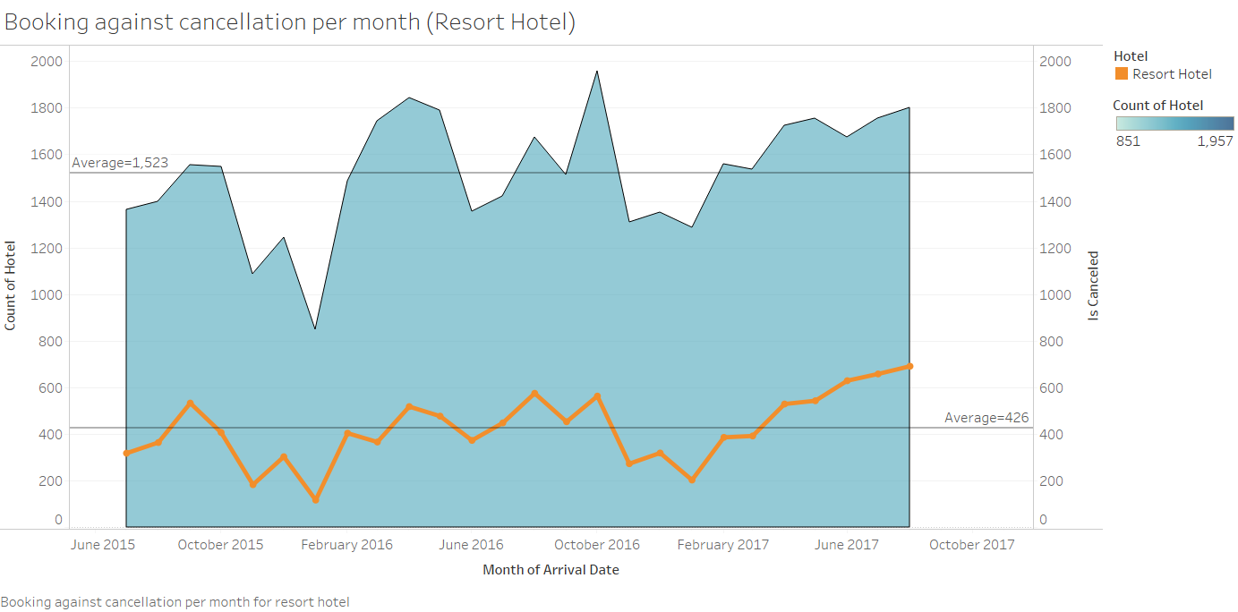

For resort hotel, we can see how the booking count and number of cancellation correllate with each other. As trend in both variables are scaling up and down together. However, the ratio of successful booking to cancellation seems to be vastly different to city hotel’s chart. In conclusion, both of the charts are made to understand the context, another type of chart is needed to find the answer to the exploratory question.

### Cancellation rate

The following charts made in this section are donut charts made with the intention to answer the exploratory question, “What is the overbooking limitation?”.

The donut chart was used here to show the cancellation rate against booking with success check outs in percentage. An alternative chart that could have been used was a traditional bar chart or a simple pie chart. However, I think the donut chart fulfils a better role in displaying the cancellation rate in a more aesthetic manner.

This chart showing the cancellation rate helps in answering the exploratory question. As it is a vital piece of information to determine the extent of how far the hotel management can take the overbooking strategy. By knowing the cancelation rate, it will assist in laying out the limitation, allowing them to gauge how much more to book in the future.

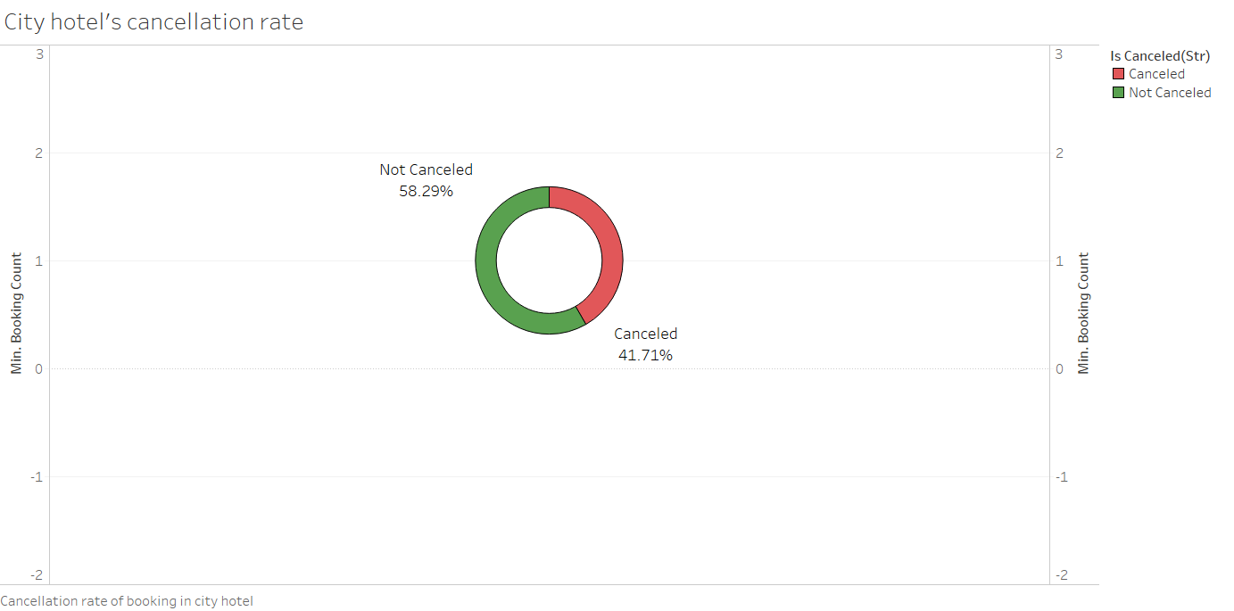

In city hotel, the likelihood of cancellation taking for a booking is at 41.71%. What this means is that hotel management should expect 2 in 5 bookings to get cancelled. While it allows more room open for overbooking, there is still thin line of messing up the strategy and suffering damages. It is recommended to overbook moderately if there is any intention of overbooking more.

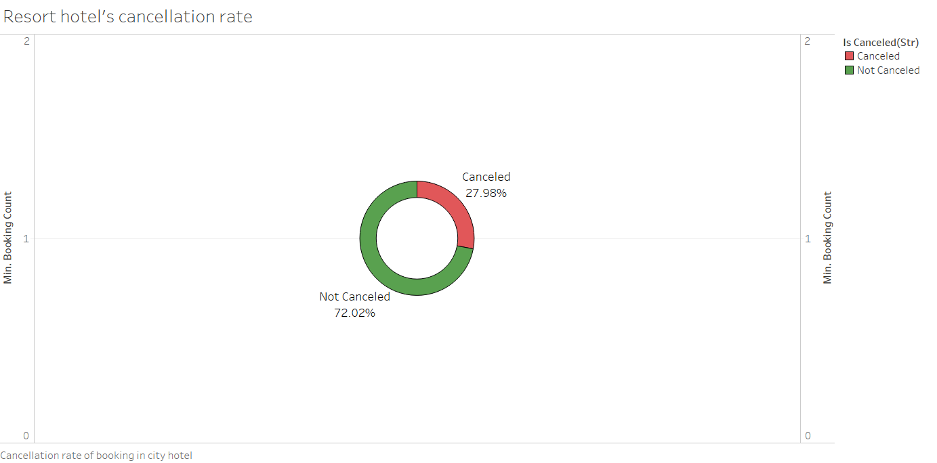

In resort hotel, the likelihood of cancellation taking for a booking is at 27.98%. Which means hotel management should expect 3 in 10 bookings to fall through and get cancelled. It shows that resort hotel receives consistent flow of successful check out as compared to city hotel. It is recommended to look for more ways to keep customer away from cancelling their stay.

### Country origin

The following chart made in this section is a symbol map made with the intention to assist in answering the exploratory question, “Based on the booking distribution, what improvement can be done?”.

The symbol map is used here to show the distribution of where the bookings came from, it gives information on where the customer country origin is. A standard map would have been fine if it was only to pinpoint the country. However, the targeting the distribution would assist in answering the exploratory question. Hence, symbol map was a better fit for this chart.

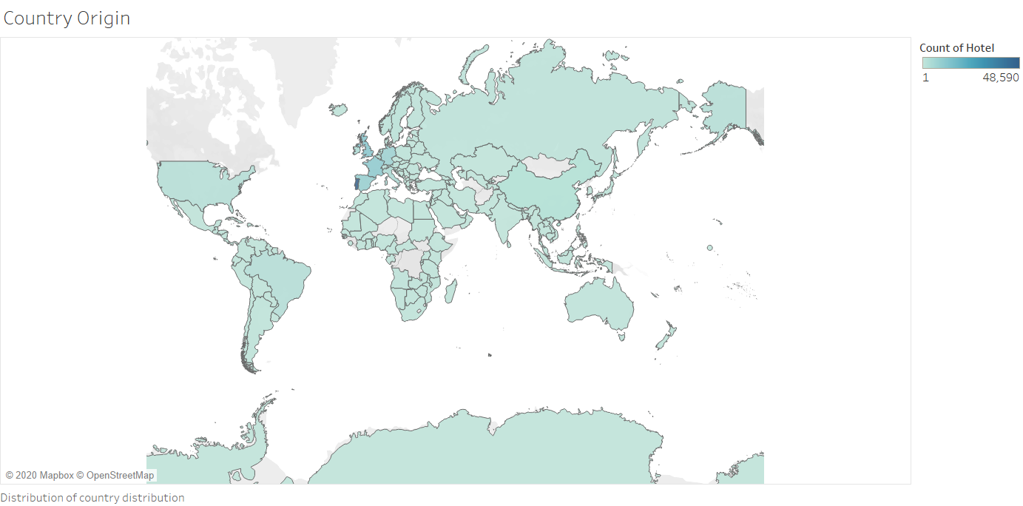

From this chart, we can see that country origin of the customer base are rather evenly distributed when looked from afar. As their roots cover most of the places on this map, including places like Antarctica, which is a small surprise. On the other hand, we can see that the country with high customer base is at Portugal with a closer look.

Initially, I would think that the country origin of the guest would interesting to look into especially if a majority were from the same region. However, it does not seem to be the case as the chart is almost evenly distributed across the globe. Nevertheless, exploring the country origin could still help with decision making. For example, advertising or business opportunity can still found if there are additional analysis done to support it.

On a side note, this visualisation could also have the potential in supporting the analysis on seasonal trend. As different region could have a seasonal vacating period that differs from each other. However, this chart in its current state is not suitable for that context.

### Market segment

The following chart made in this section is a tree map made with the intention to assist in answering the exploratory question, “Based on the booking distribution, what improvement can be done?”.

The tree map used here is to explore distribution of the market segment between each hotel. A stacked bar chart might do the trick for this visualisation but this tree map gives a change in scenery of the way I can create visualization.

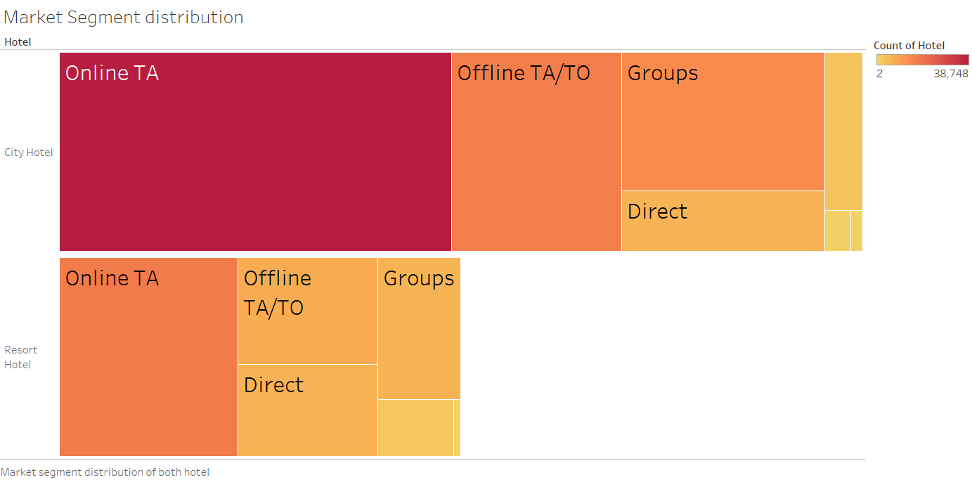

In this chart, we can see the similarity in how the segments with the top two highest contribution is Online TA and Offline TA/To for both hotels. While both hotels differ in the remaining segments, where city hotel work more with Groups instead of Direct and resort hotel was the other way round. A small notable finding is that the 2 to 1 ratio of booking count size between city and resort hotel can be seen here. The total size of city hotel is visibly twice of what the resort hotel has.

This tree map has supported in answering the exploratory question by allowing the target to gain awareness of how the market they are working with is distributed. The management can draw their attention to segments that they are considering to focus on. They can also explore any other business opportunity can be derive from this chart.

### Distribution channel

The following chart made in this section is a pie chart made with the intention to answer the exploratory question, “Based on the booking distribution, what improvement can be done?”.

The pie chart was used to describe the distribution channel dimension, displaying which channel the booking came from. A bar chart would have sufficed to showcase the channels and their values. However, using pie chart is easier to visualise the portion of each channel within the context of all channels available.

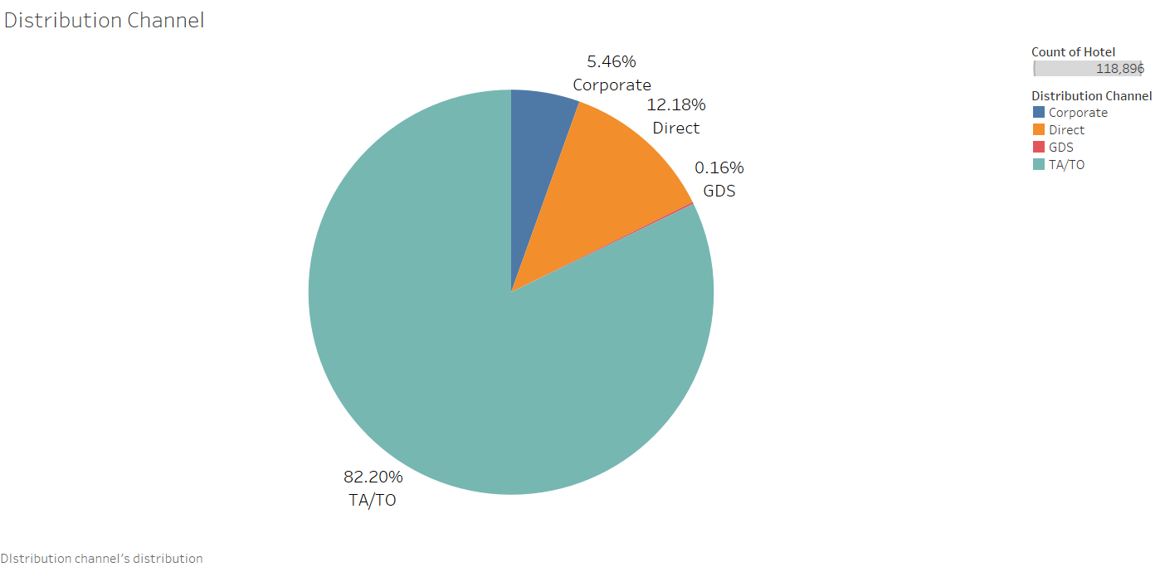

In this chart, we can see the TA/TO dominating the distribution channel, signifying 4 in 5 booking came from TA/TO. Considering that both TA and TO holds majority in the market segment as well, it is expected to see more bookings that came from there.

To answer the exploratory question, I would suggest exploring GDS as a place of interest for improvement. Since there is untapped potential to utilise the GDS to streamline the booking channel into one. The GDS is a great platform to book corporate travel due to its efficiency. It is also capable of generating more bookings compared to direct channels. Reason being the information on availability and rates are easy to find for travel agency. With all information stored together, it makes work easier for travel agent to find hotels that fits the client’s needs. Hence, there is a growing popularity with travel agents as well. Making it all the more important to use GDS since the biggest distribution channel may turn to GDS. This suggestion ultimately may eliminate the risk but the incorporation of both utilizing GDS and the overbooking strategy is possible. Which is a further development after exploration on the use of GDS for the hotel management.

### Reserved Room against Assigned Room

The following charts made in this section is a cross tab made with the intention to answer the exploratory question, “What has been done to deal with overbooked customers?”.

The cross tab was used to show how many bookings were actually assigned to their reserved rooms. It is an indicator if overbooking took place and customer were given rooms other than the one that was booked. In my opinion, the cross tab was best way to visualize the indicator and colours were used to highlight cells that were matching the variables. However, an additional donut chart is also made to support the visualising the matching frequency rate. It is created to easily get information on how often overbooking take place.

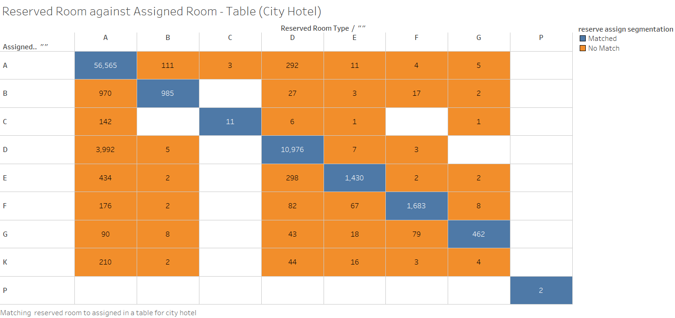

From here, we can see that each of the reserved room were actually assigned as it matching values outweighs the remainders in each column. Interestingly, we can find that there are rooms which is not available for reservation in K type rooms. It is likely those rooms are used in case of overbooking, acting as emergency operational room inventory. Another interesting finding is that room type P could be some sort of executive room type. As it is the only room type that fulfils its reservation and it has a meagre number of 2 booking made for it.

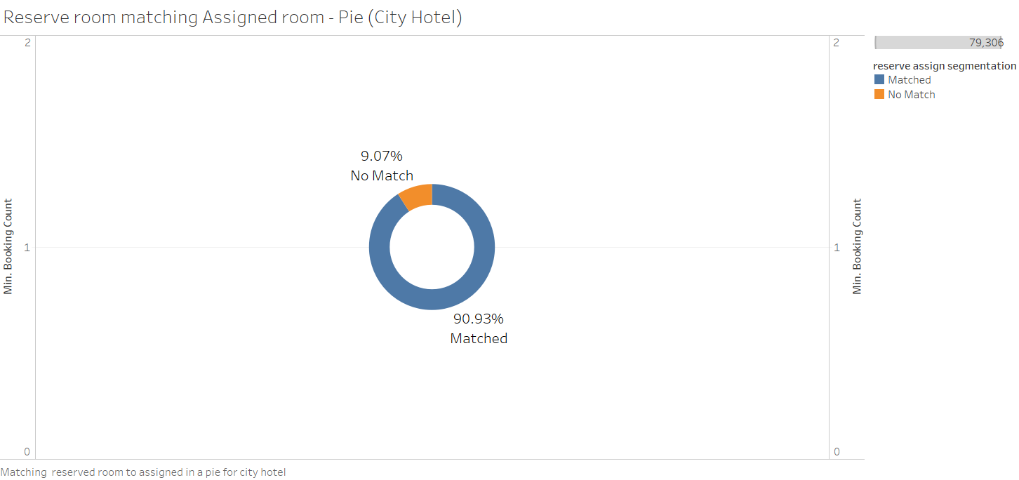

With this donut chart, we can see that only about 1 in 10 bookings are considered overbooked in city hotel. Considering how much booking are cancelled on average in city hotel, this reflect how risky the city hotel’s overbooking strategy is. As they provide the room despite having close to half of the bookings getting cancelled. If the rooms ended up not being cancelled, the city hotel could have a big overbooking issue.

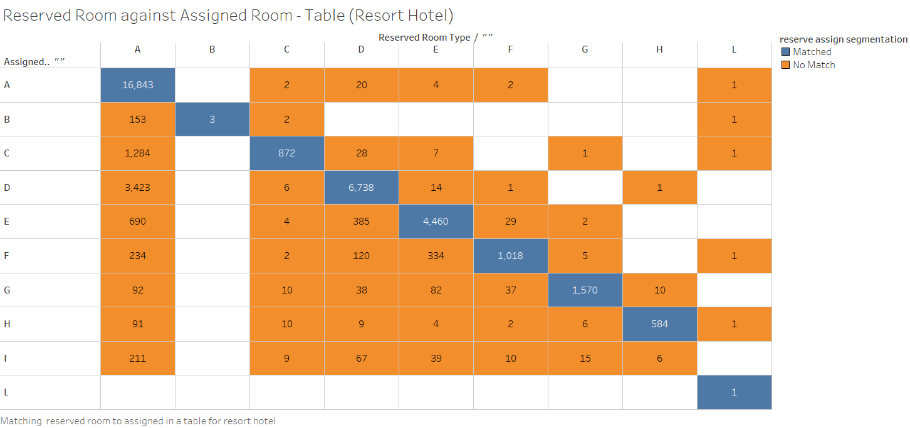

For resort hotel, looks to be the same as city hotel on the surface, where most of the reserved room are assigned. Similar finding is that the room type B here seems to hold the same status as room type p in city hotel. Room type L here in resort hotel seems to have limited availability or limited in terms of numbers.

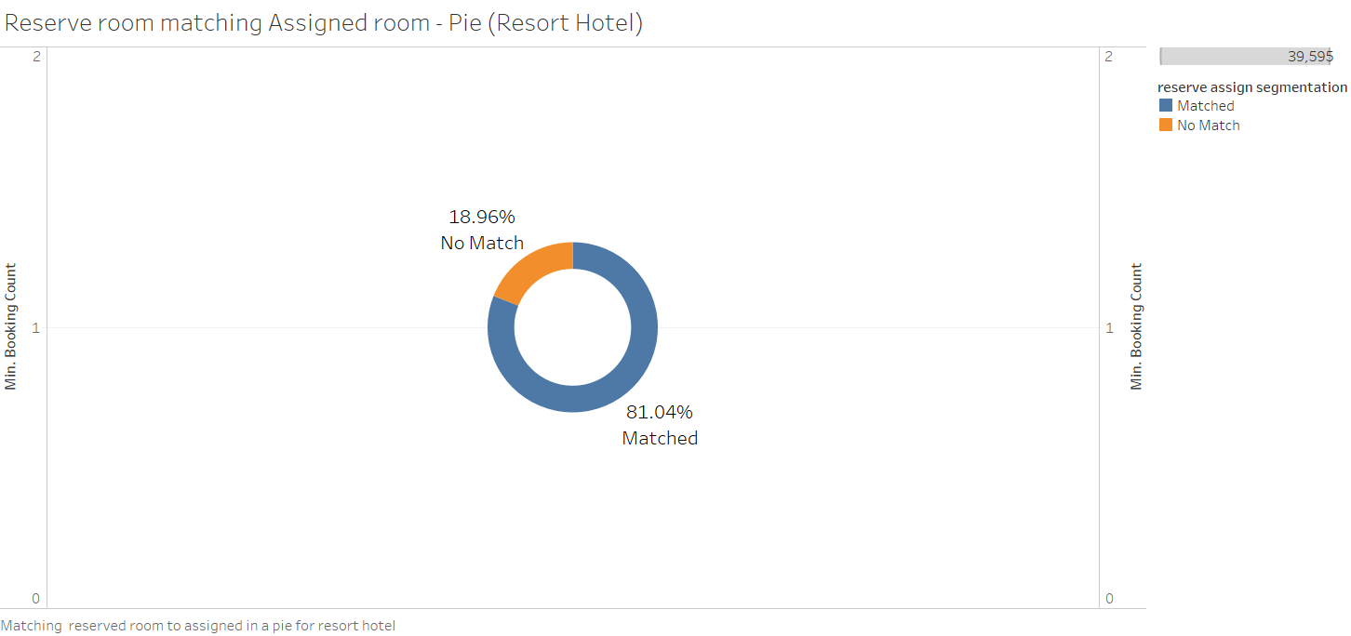

Surprisingly, 1 in 5 bookings are overbooking in resort hotel, chances that is twice of city hotel. Which is weird considering resort hotel having a lower cancellation rate but there is a higher chance of not getting the reserved room. Meaning that resort hotel’s overbooking strategy is not optimize to its full potential. An expected result is to have more reserved room being actually assigned to.

### Deposit type distribution

The following chart made in this section is a packed bubble chart made with the intention to understand the exploratory question, “What has been done to deal with overbooked customers?”.

The chart was used to give variation of visualisations in this report, while another type of chart would have served the same purpose. Using this pack bubble chart gives a refreshing look especially after chart of traditional bar chart or pie chart has been used.

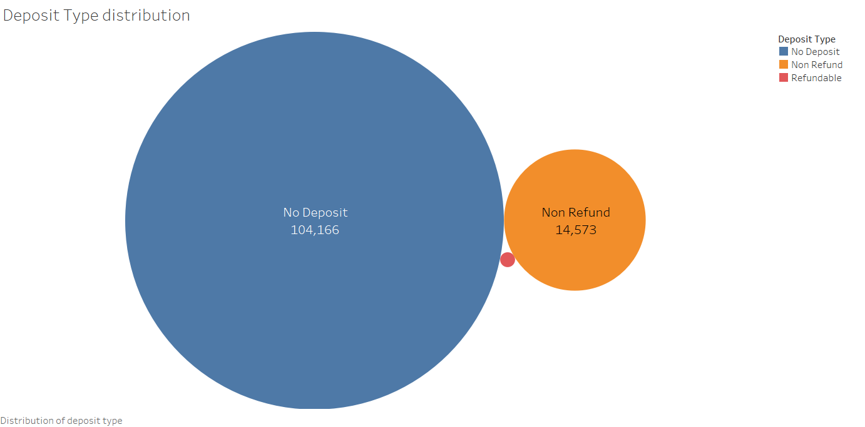

From this chart, we can see that majority of deposit type were no deposit or non-refunds. There is hardly any refundable booking, which is understandable as hotels want keep as much revenue from being refunded. It seems that in case of overbooking, methods other than refunds were deployed to minimise PR damages.

A favoured method could be upgrading customers to another room type during their stay. It is a plausible method as supported by chart on reserved room against assigned room. The mismatch room types could have been due to overbooking changing their room type. Building on the assumption of city hotel’s special room type K, hotels can also prepare special rooms to be used in overbooking cases.

### Customer type distribution

The following chart made in this section is a bar chart made to understand the customer type.

A traditional bar chart was used here to display the distribution of the customer type, allowing us understand what sort of customer the hotels are dealing with. A stacked bar chart could have been a viable option but some of the values were so small that the contribution was hardly visible. Hence, the traditional bar chart was better fit to convey the distribution in this visualization.

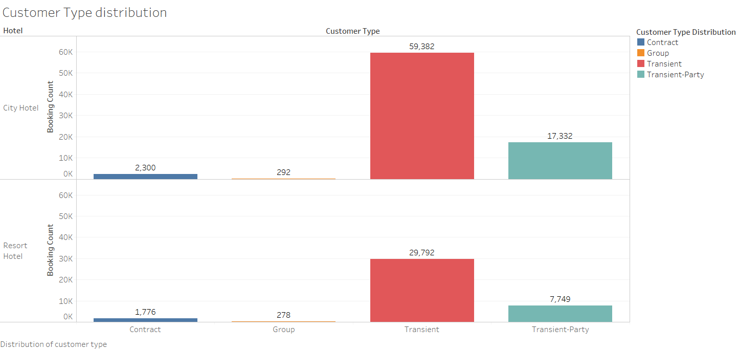

From this chart, we can see that most booking made were of transient customer type for both hotels. This shows that most booking were independent and carried out without any contractual binding to it. Which would mean when compensations are made due to overbooking, it is not as restrictive on available option. Such that if the bookings were to be affiliated with others parties or contract based, upgrading rooms could be difficult. Even walking guest by recommending other hotels in the proximity could be tough, as there may not be enough rooms to house a group of guests.

## Explanatory question list refresher

1. What are some seasonal trends of bookings?
   * Booking counts
   * Guest to booking count (children)
2. What is max availability of operational rooms for each hotel?
   * Highest number of booking in each month (City Hotel)
   * Highest number of booking in each month (Resort Hotel)
3. What is the overbooking limitation?
   * Booking against cancellation per month (City Hotel)
   * City hotel’s cancellation rate
   * Booking against cancellation per month (Resort Hotel)
   * Resort Hotel’s cancellation rate
4. Based on the booking distribution, what improvement can be done?
   * Country origin
   * Market segment
   * Distribution channel
5. What has been done to deal with overbooked customers?
   * Reserved Room against Assigned Room (City Hotel)
   * Reserved Room against Assigned Room (Resort Hotel)
   * Deposit type distribution
   * Customer type distribution

# Dashboards

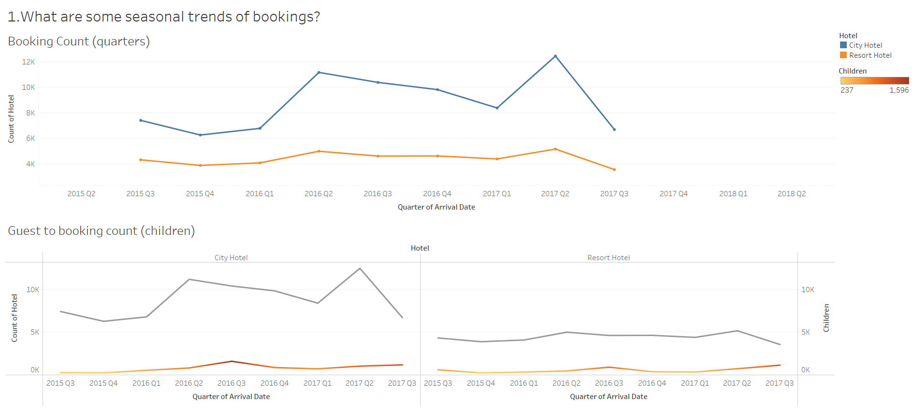

Top chart – Booking count (quarters)

* Display booking count of both hotels by quarters

Bottom chart – Guest to booking customer (children)

* Left chart is for city hotel, right is for resort hotel
* Lower line is made to compare children count against bookings

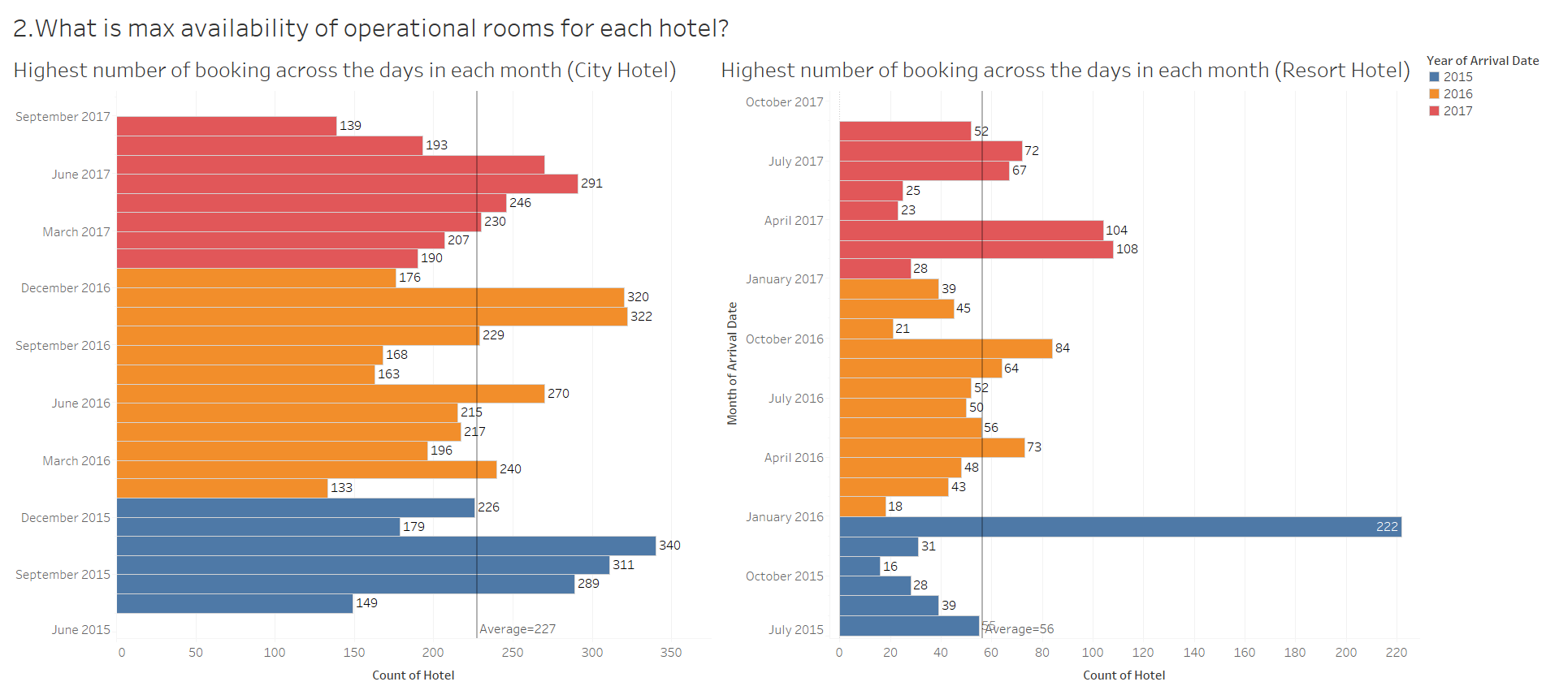

Highest number of booking in each month

* Left chart is for city hotel, right is for resort hotel
* Average line is made to answer exploratory question

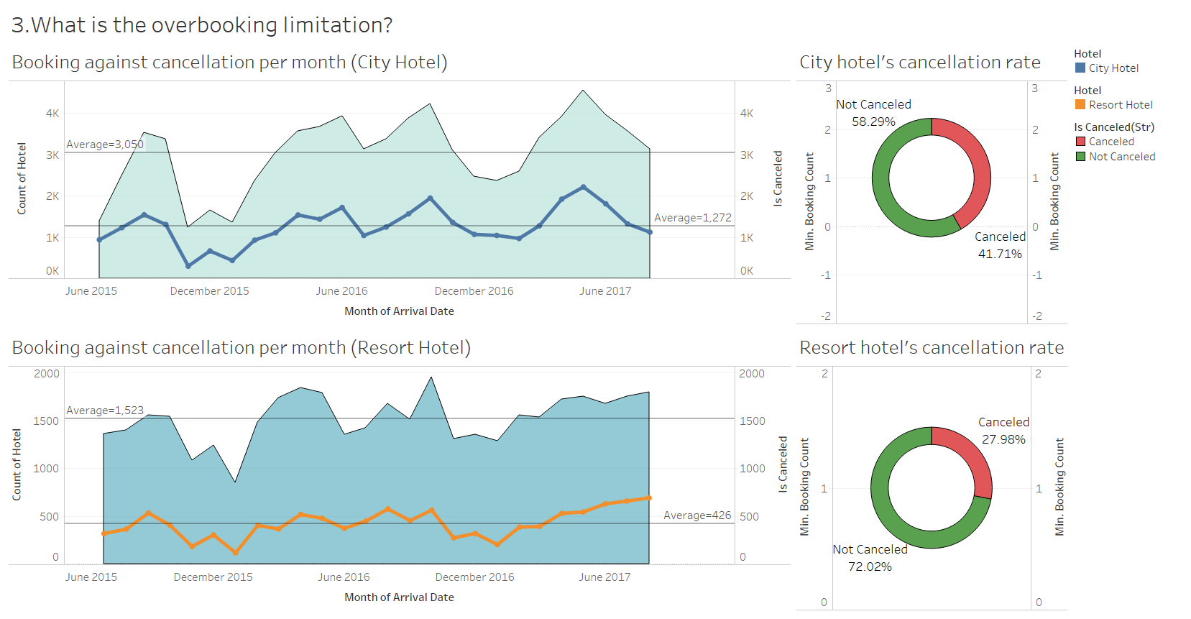

Top left – Booking against cancellation per month for city hotel

Top right – Cancellation rate in city hotel

Bottom left – Booking against cancellation per month for resort hotel

Bottom right – Cancellation rate in resort hotel

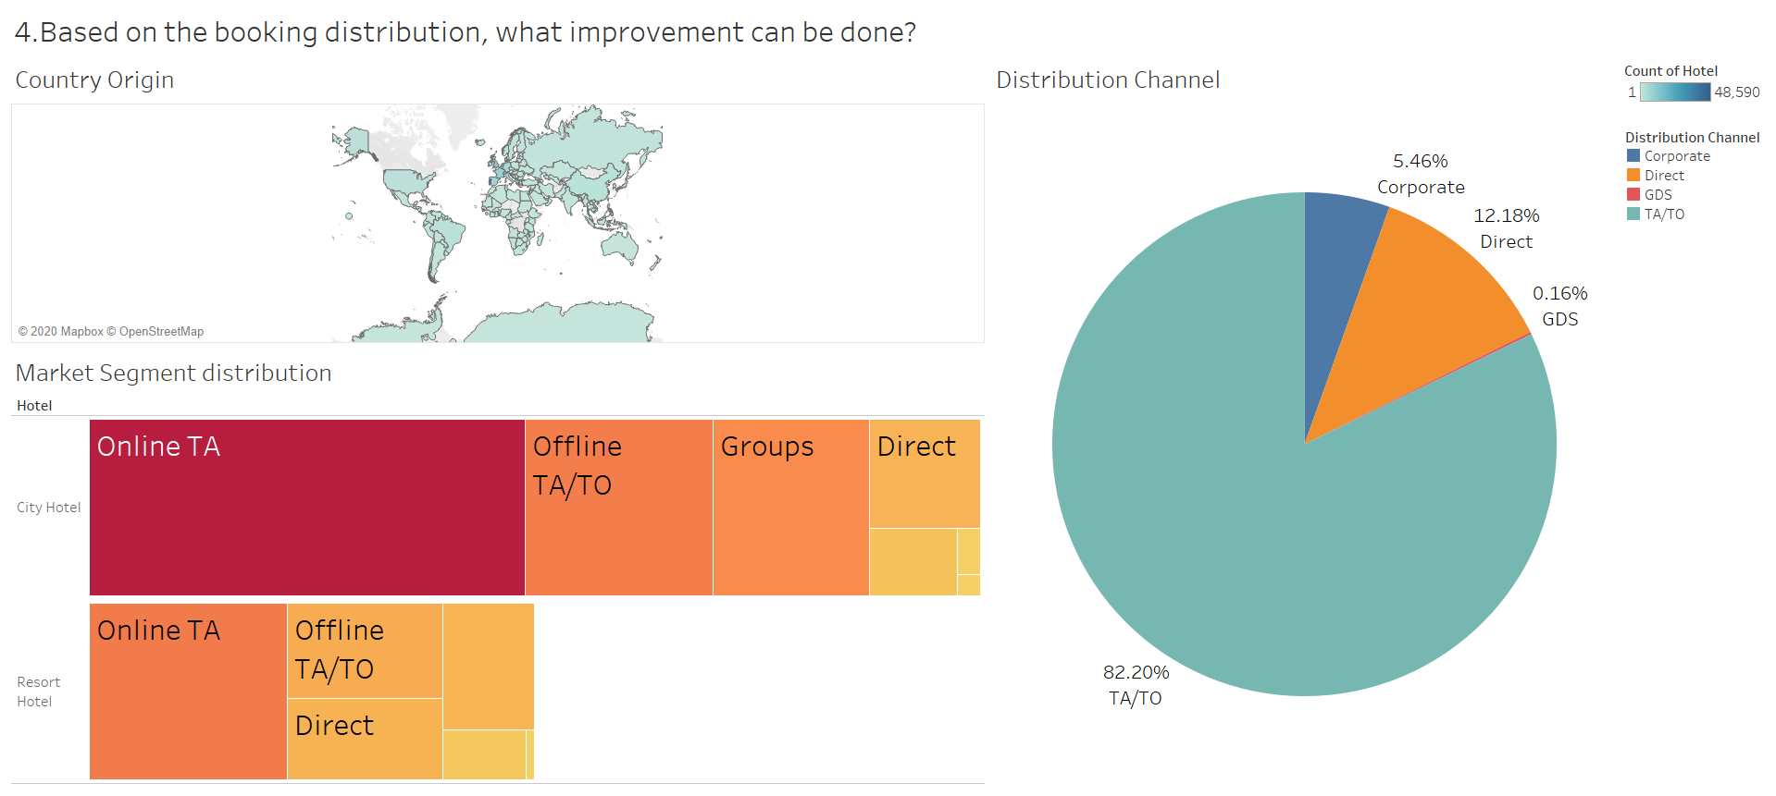

Top left – Distribution of Country Origin

Bottom left – Distribution of Market Segment

Right – Types of Distribution Channel

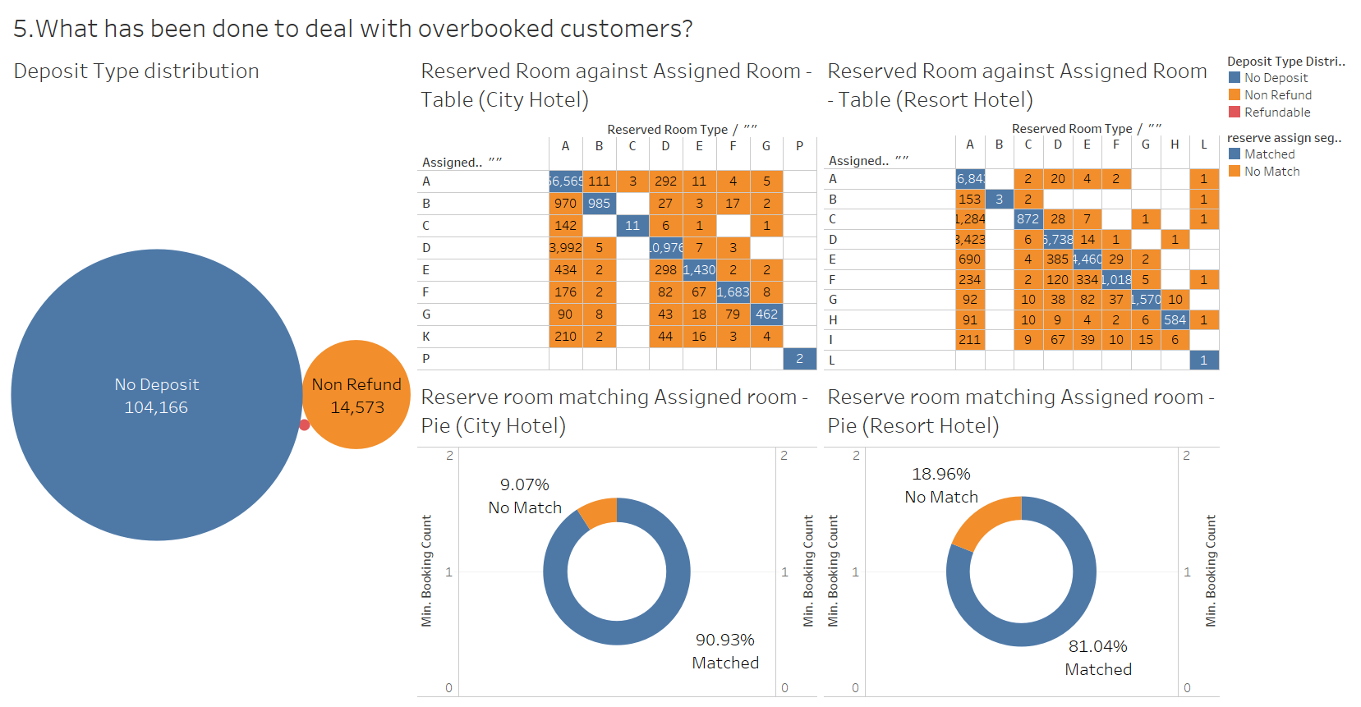

Top left – Distribution of Deposit Type

Top right – table matching reserve rooms and assigned rooms

* Left chart is for city hotel, right is for resort hotel

Bottom right – Matching rate of reserve room against assigned room

* Left chart is for city hotel, right is for resort hotel

# References

*GDS hotel: What is a global distribution system?* (n.d.). Retrieved from www.siteminder.com: https://www.siteminder.com/r/global-distribution-system/